**G51DBI**

**Databases & Interfaces Report**

Team Members:

|  |  |
| --- | --- |
| Name | Student ID |
| Loh Jin Xian | 016763 |
| Lim Zhi Fu | 025291 |
| Leong Hoi Fei | 017565 |
| Bryan Foong Jia Ming | 017622 |
| Amirul Umar Bin Pandai | 023484 |
| Tan Kheng Hau | 014719 |

**Table of Content**

1. **Introduction**
   1. About us
   2. Purpose
   3. Project Scope
      1. Project Objective
      2. Goal
      3. Task
2. **Scenario Case Study**
3. **User Interface & Website Design Documents** 
   1. Prototypes
   2. Mid Fidelity
   3. Functional & Non-functional Requirements
   4. ER diagram
   5. Database Model Diagram
   6. Finalised User Interface
      1. Homepage
      2. Movie page
      3. Booking page
      4. Refreshment page
      5. Payment page
      6. About us page
   7. Data Flow of the Website
4. **Feature Overview**

1. **Website’s setup tutorial**
2. **References**
3. **Introduction**
   1. **About Us**

The name of our company is Deadat28. Our company was founded in March 2017 by six young students from University of Nottingham Malaysia. Our company’s motto is “Be Better than Yesterday” and we are passionate in creating evolutionary modern website for the users. We love experimenting new features that could make the world a better place. Our company is based in Kuala Lumpur, Malaysia.

* 1. **Purpose**

The purpose of this website is to create a premium cinema website for the newly established movie company, Movie Scope. This website will enable anyone to buy tickets and enjoy all the latest movies in a high-class environment that is specially crafted by interior designer from Sweden.

* 1. **Project Scope**
     1. **Project Objective**

We are required to create a website that is user-friendly to the users and redesign the process of buying tickets from the cinema, changing the traditional way of thinking, making things simple and efficient.

* + 1. **Goal**

The goal of this website to provide users a comfortable base to make their purchases without having to click through unnecessary buttons or advertisements that affect the user experience. Every design in the website is simple yet elegant.

* + 1. **Task**

Tasks are divided into five major categories:

1. **User Interface designer**

For this section, Bryan Foong Jia Ming and Leong Hoi Fei are responsible for the overall design of the project. They will be handling the arts and transitions that will be featured in the website, making everything look neat and clean to the eyes of the user.

1. **Database administrator**

Database design and implementation will be mainly handled by Lim Zhi Fu. He will be designing a new database system that will store and send all the information collected between the database and the website. All critical information is stored here, making database administrator one of the most important role in the project.

1. **Requirements engineer**

Tan Kheng Hau is responsible for getting feedbacks from the users on what could be improved in our current cinema’s websites that are available in Malaysia like TGV, GSC cinema. Then, he will design the flow of the website according to the feedbacks. At the same time, he will create an ER diagram that is needed to supplement the implementation process of the whole website.

1. **Web programmer**

The foundation of a website outlook will be programmed by Amirul Umar. He will handle the coding part of the website, mainly HTML5, CSS, Javascript and JQuery. Then, the website is further enhanced by the user interface designers. He is also responsible for the efficiency and effectiveness of the codes, keeping an eye on all changes made to the website.

1. **Project Manager**

Loh Jin Xian is the project manager of this project. He will oversee everything from the design of the website to the design of database, making sure everything is made according to plan. When team members need help, he will be the one providing a solution or make tough decisions that could make an impact on the overall website. He is required to take extreme ownership of the whole project. If there’s any mistakes regarding the website, he needs to take responsibility and explain it to the client.

1. **Scenario Case Study**

A client named Mr Hani Parhizkar Behrang has requested us to create an ecommerce website for a cinema that is newly opened. Below are his required specifications:

**Specification:**

1. A website that enable user to book and purchase movie tickets

* Website must have at least 3 movies available
* User can choose the date, time and seats for the movie
* Movies’ info is listed and trailer for the movie is provided
* User can cancel their purchase

1. Snacks available for user to purchase in the website

* User can Select package movie deals that comes with drinks and snacks
* Different variety of snacks and drinks for the user to choose from

1. Input user details when purchasing items
2. The website must be able to work on a localhost and a personal computer

The website must be completed by 30th April 2017, which is the date when the website will be launched for the use

1. **User Interface Design Document**
   1. **Prototypes**

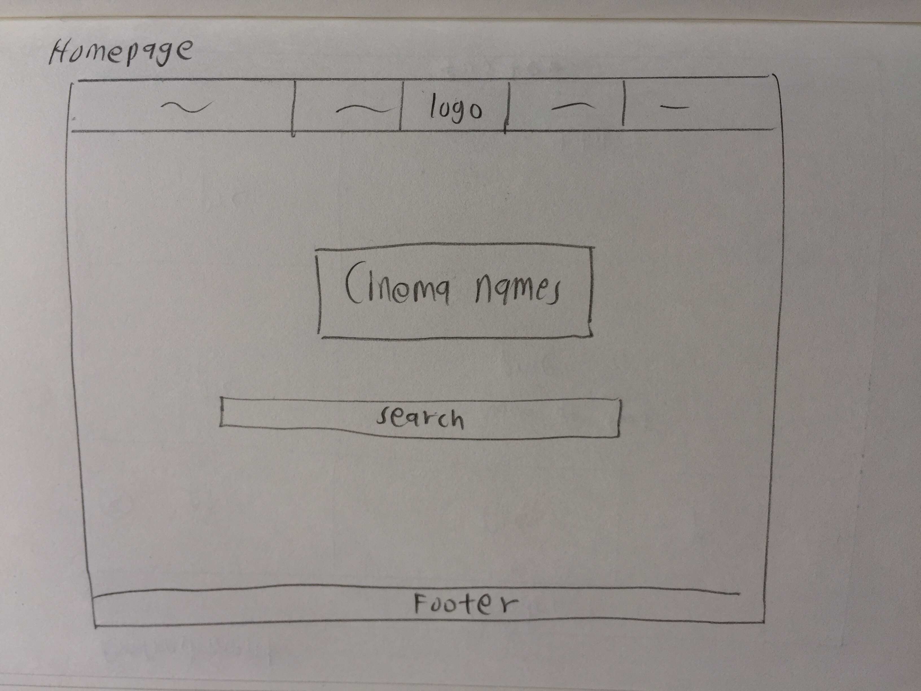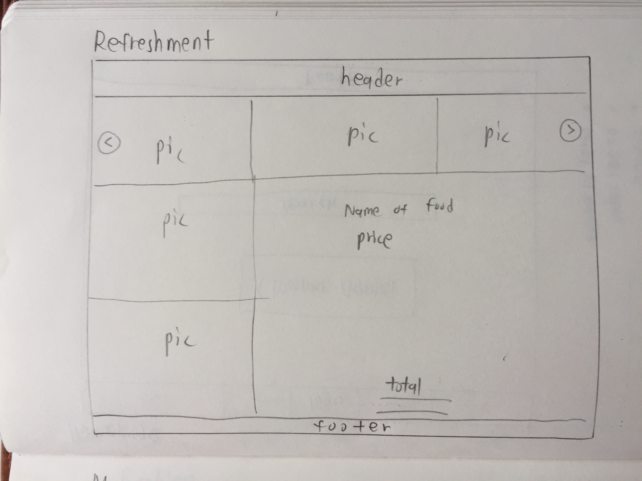

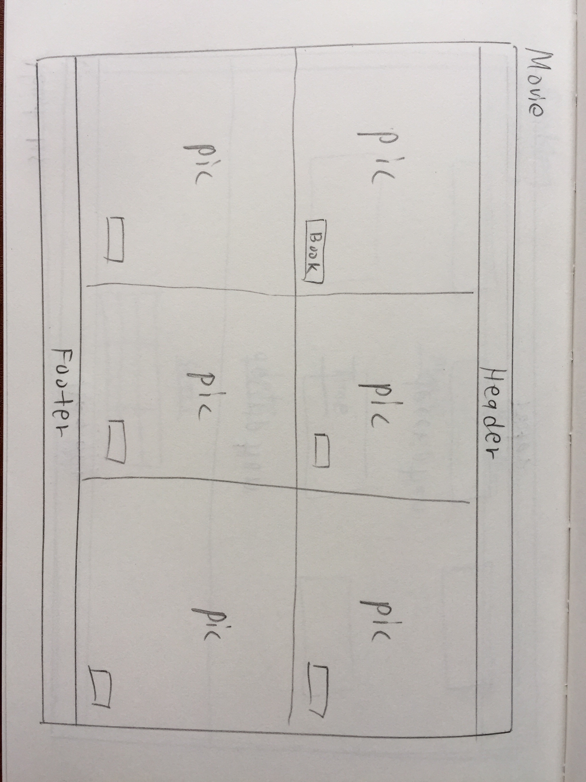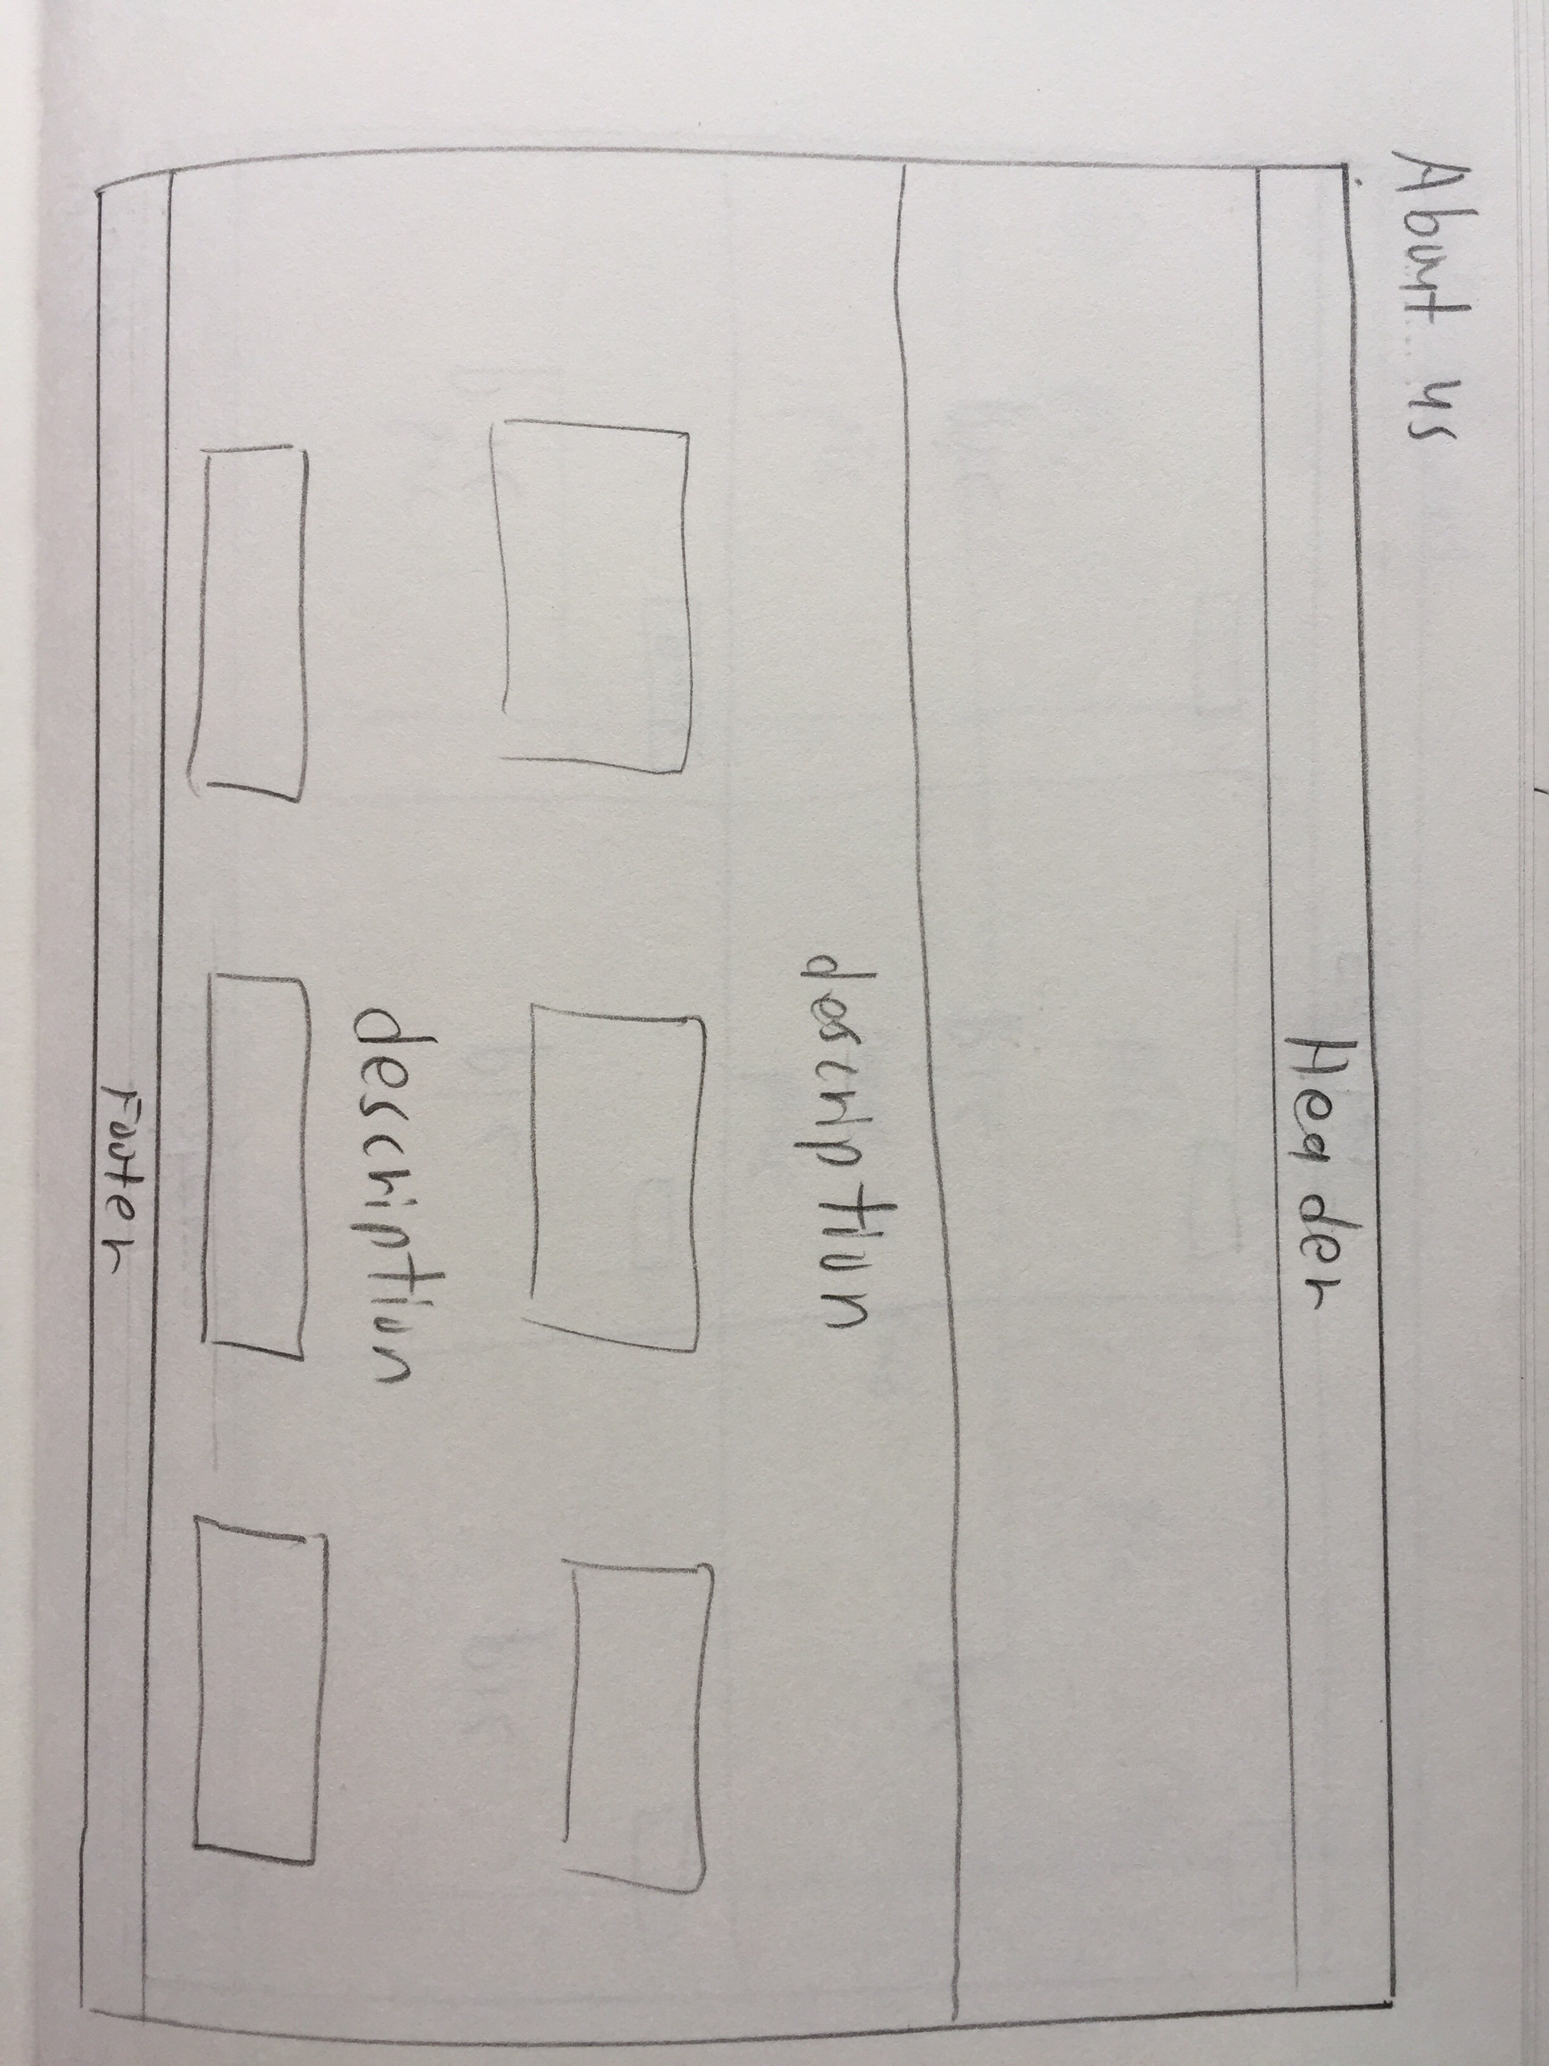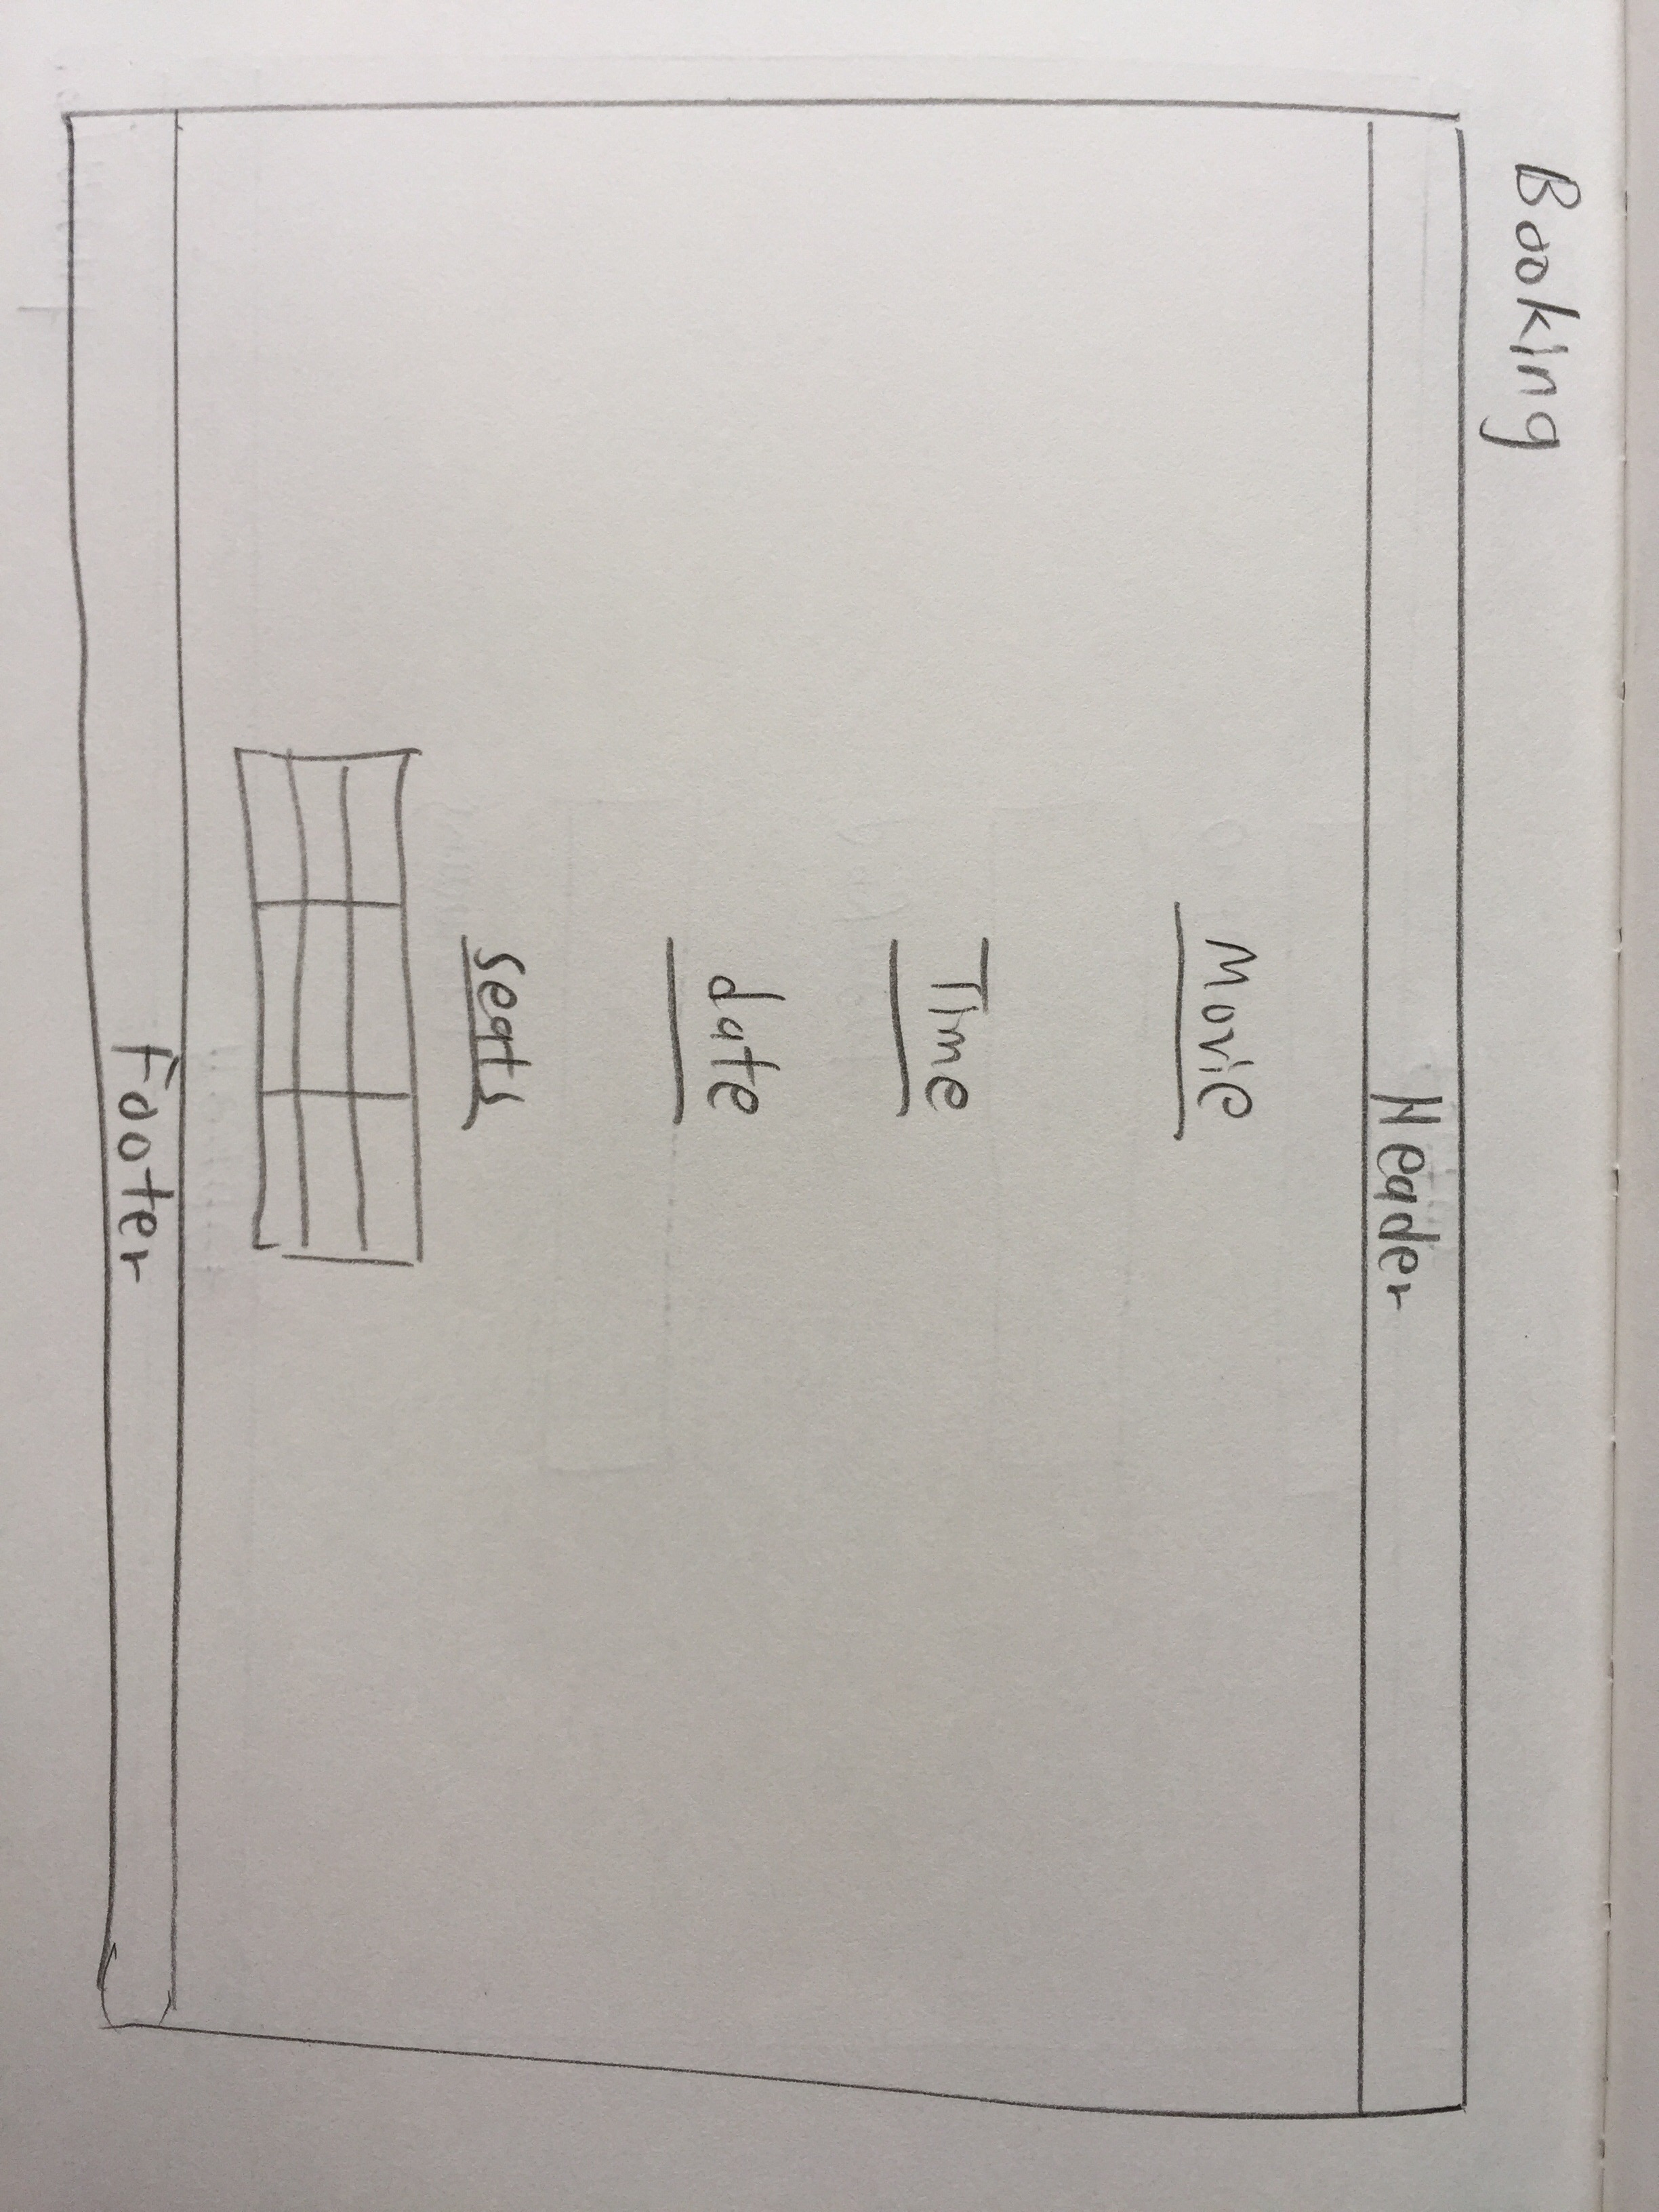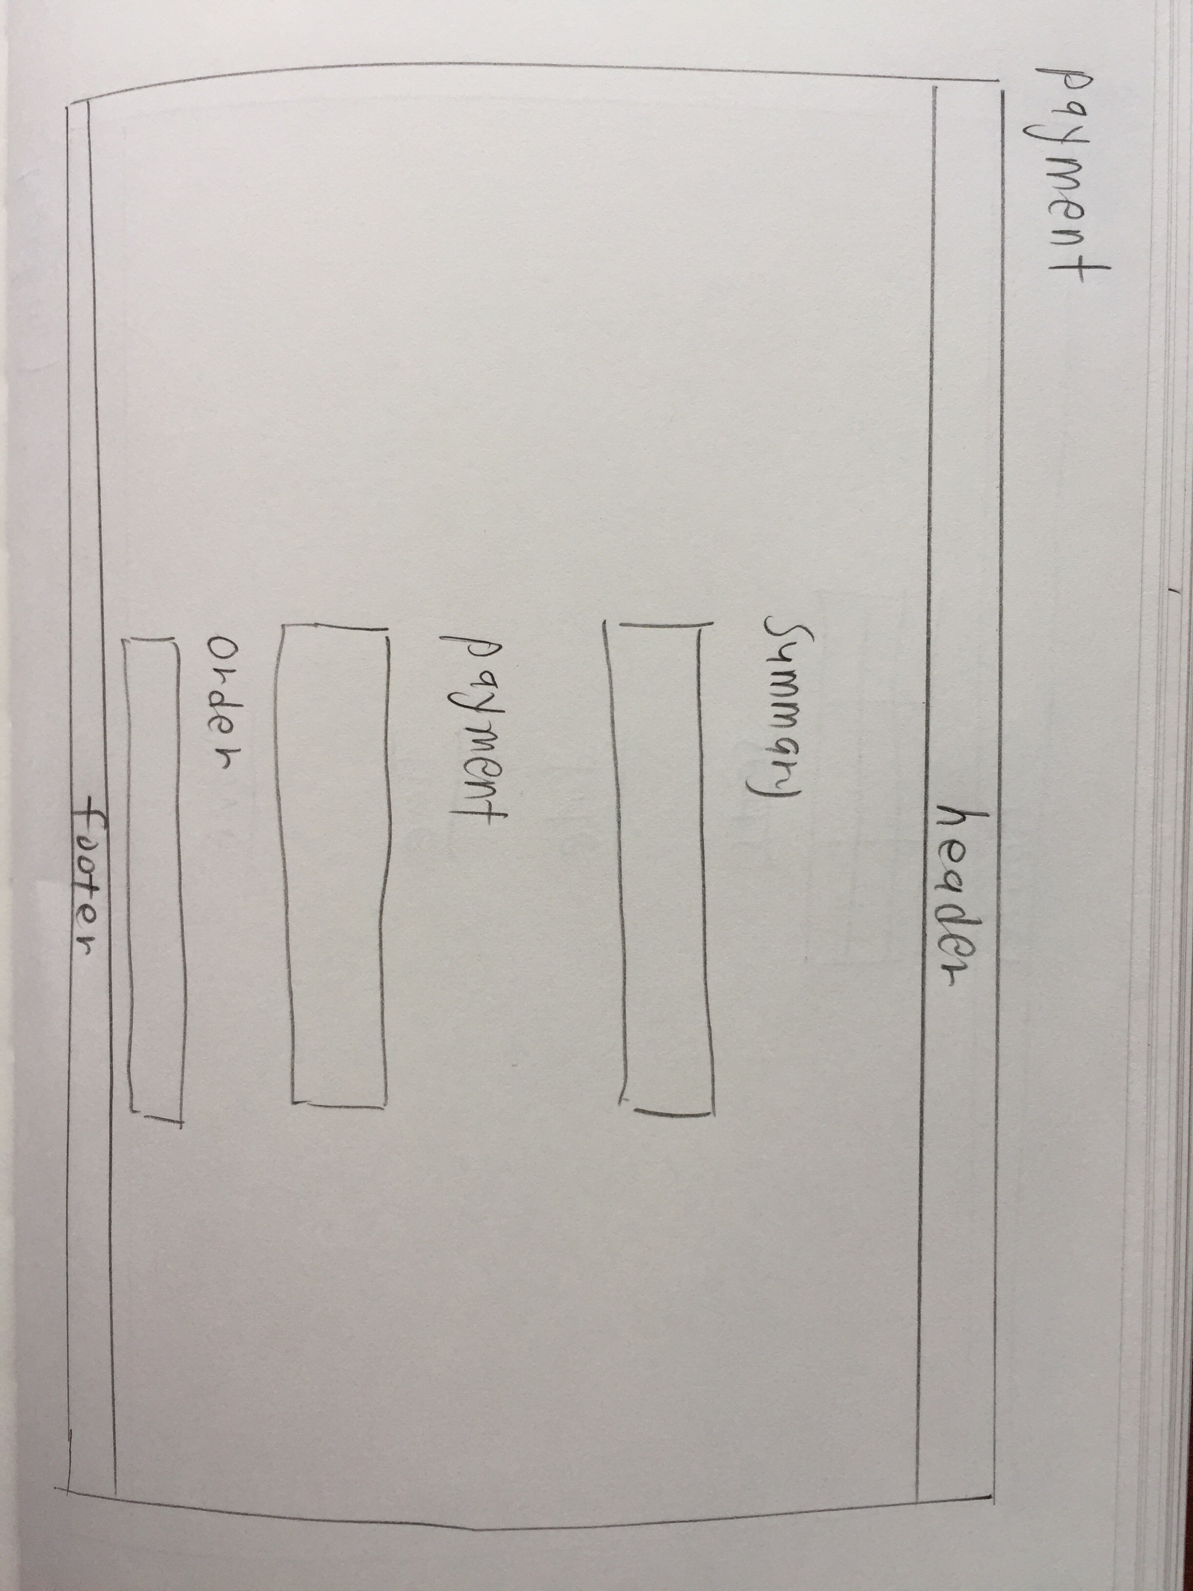

* 1. **Mid Fidelity**

**Homepage**

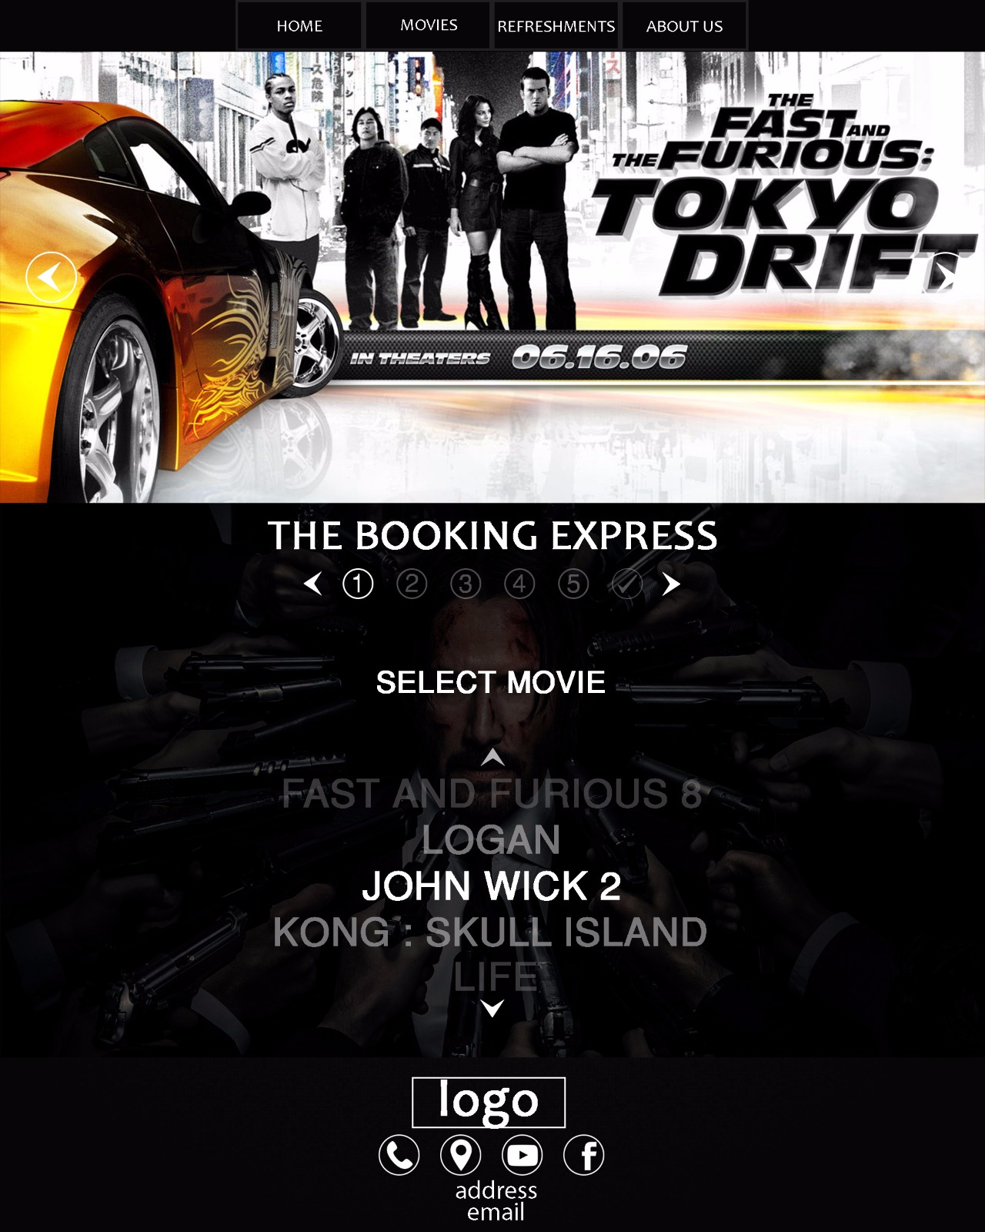

**Refreshment page**

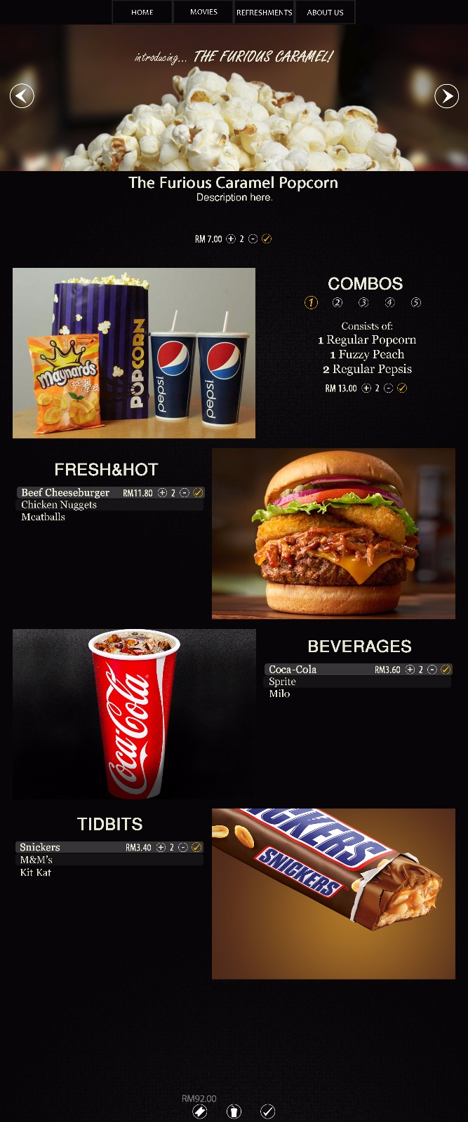

**Booking page**

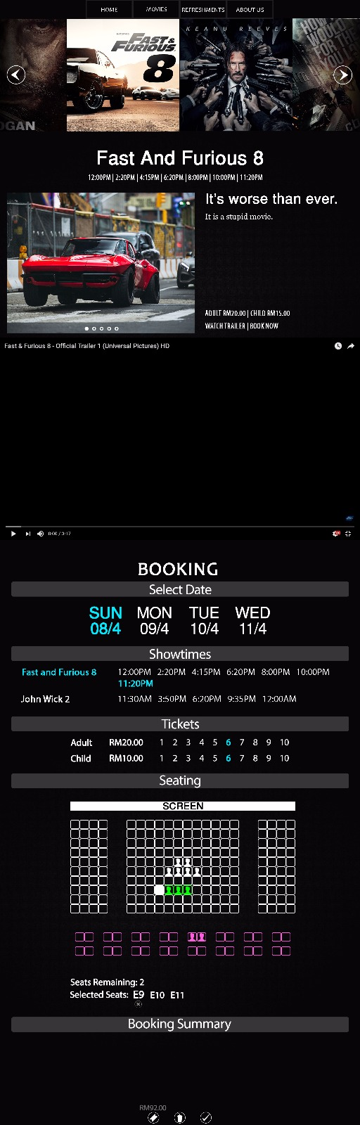

**About us page**

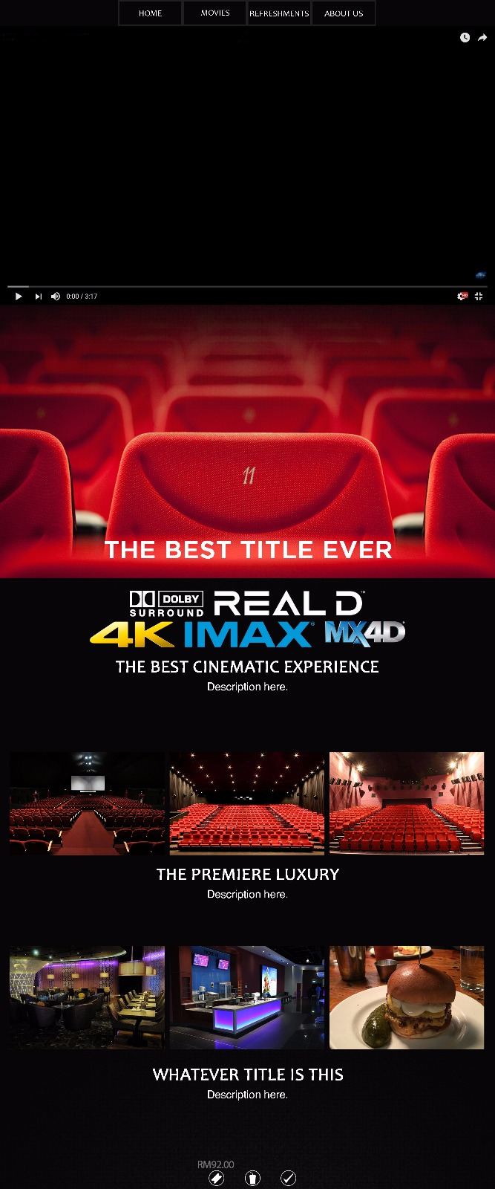

* 1. **Functional & Non-functional Requirements**

1. Functional requirements

* The website can accept user’s movies and refreshments’ orders
* The website can calculate the total cost of what user purchases
* The website allows user to choose the time, date and movie that they want to watch
* The website allows user to cancel or confirm their purchase at the checkout page

1. Non-functional requirements

* The time taken for the website to load is not more than 5 seconds
* The website is easy to use by all type of users
  1. 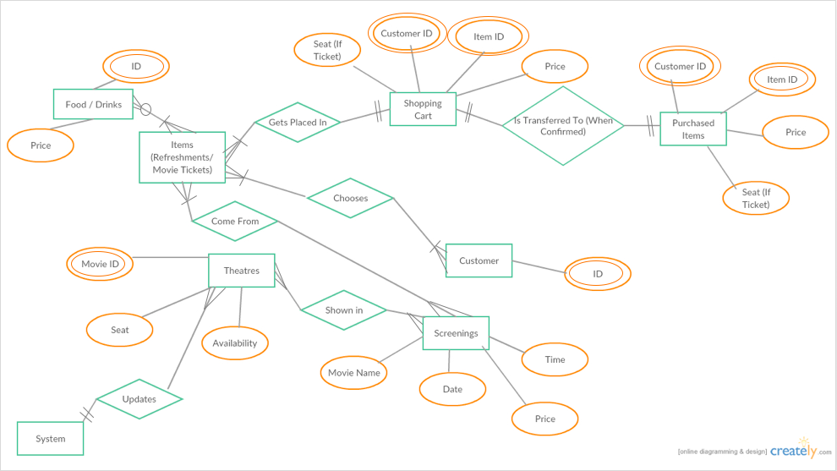**ER Diagram**
  2. 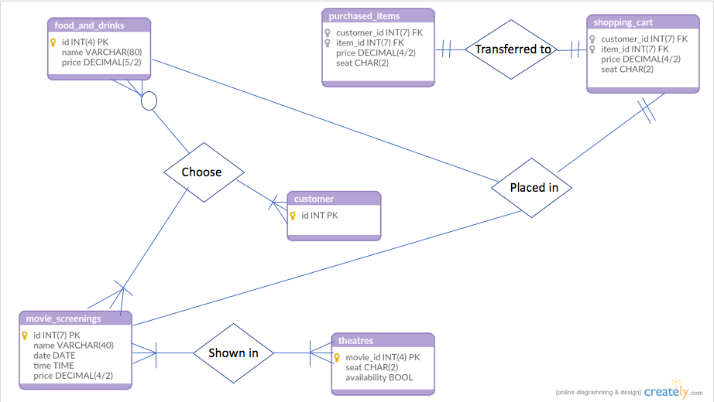**Database Model Diagram**
  3. **Finalised User Interface**
     1. **Homepage**

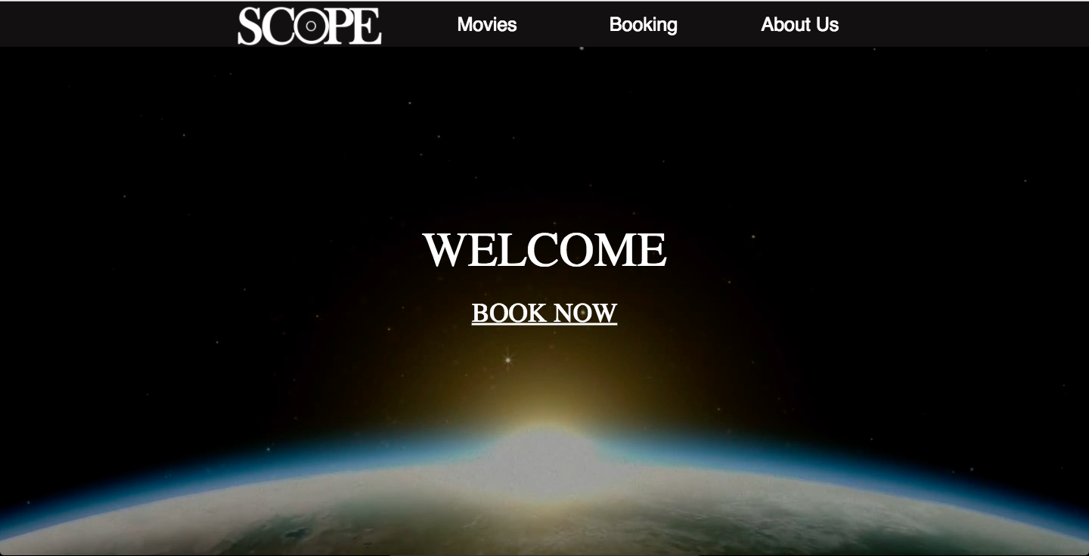

* + 1. **Movie page**

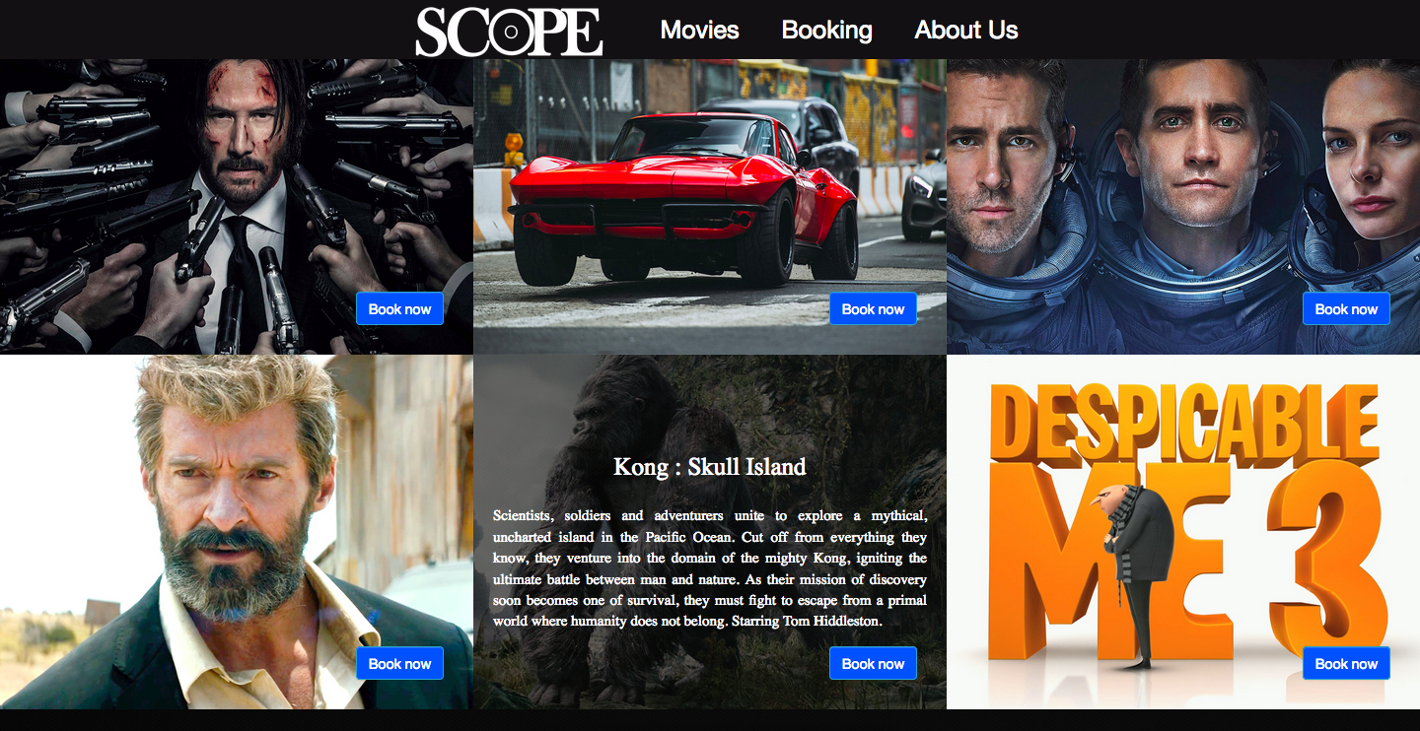

* + 1. **Booking page**

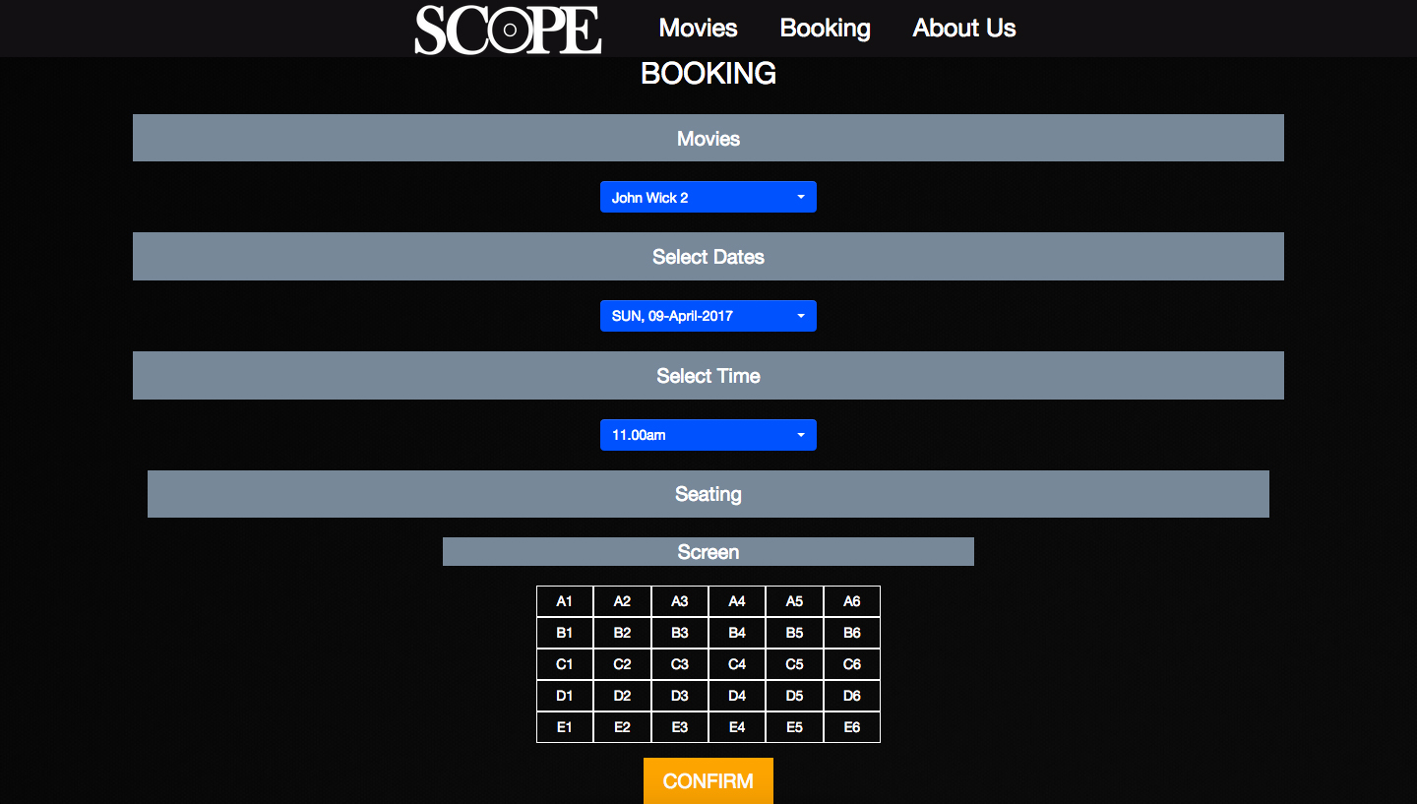

* + 1. **Refreshment page**

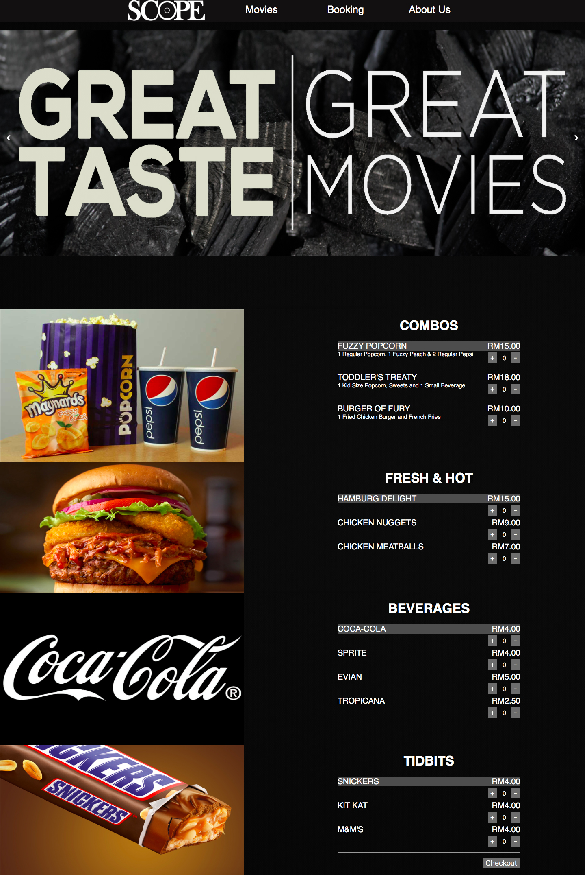

* + 1. **Payment page**

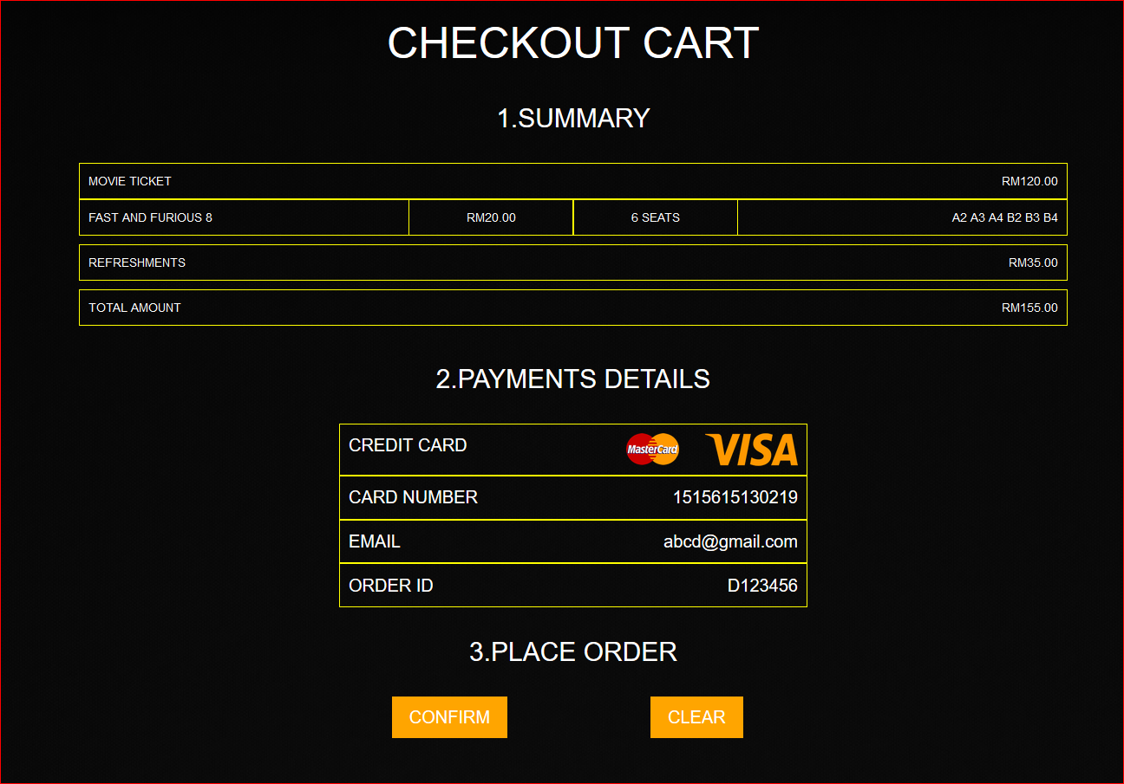

* + 1. **About us page**

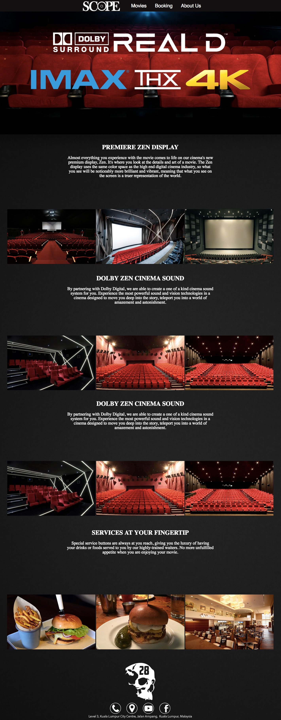

* 1. **Data Flow of the Website**

The design of our website can be categorised into 2 categories:

1. Movie-based visitor
2. Timing-based visitor.

Therefore, the data flow of our website varies depending on the type of user that visit our website.

Our website is designed to be simple and user-friendly to different type of user. Our website adapts to the needs of the user by having 2 ways of interacting with the website. For user that just want to watch the movie that they have decided, they can just click the ‘Book Now’ button at the homepage to be redirected to the booking page without having to click through different pages. Clicking the ‘Scope’ logo brings user back to the homepage.



Click Here

Instant Ticket Booking

For user that want to explore movies that are new or interesting, they can click on the ‘movie’ section to have a detailed look on the movies descriptions and posters.

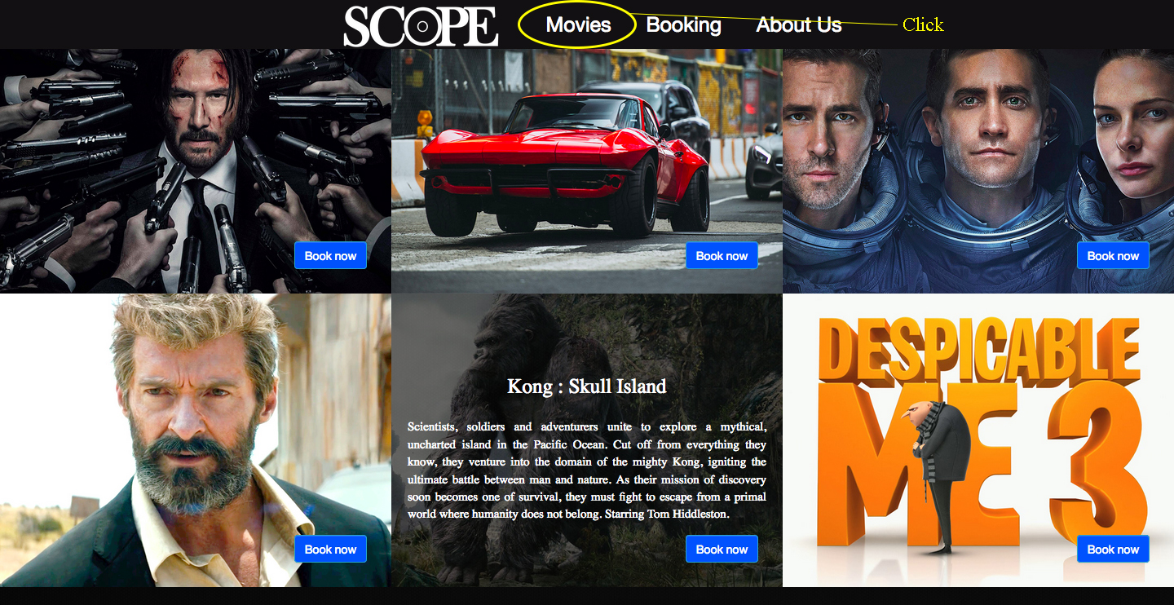

For both categories, once they selected their movie at the booking page, they will be taken to the refreshment page to buy any additional food and drinks.

After that, they will be taken to the checkout page to finalise their purchase for both movie tickets and refreshments.



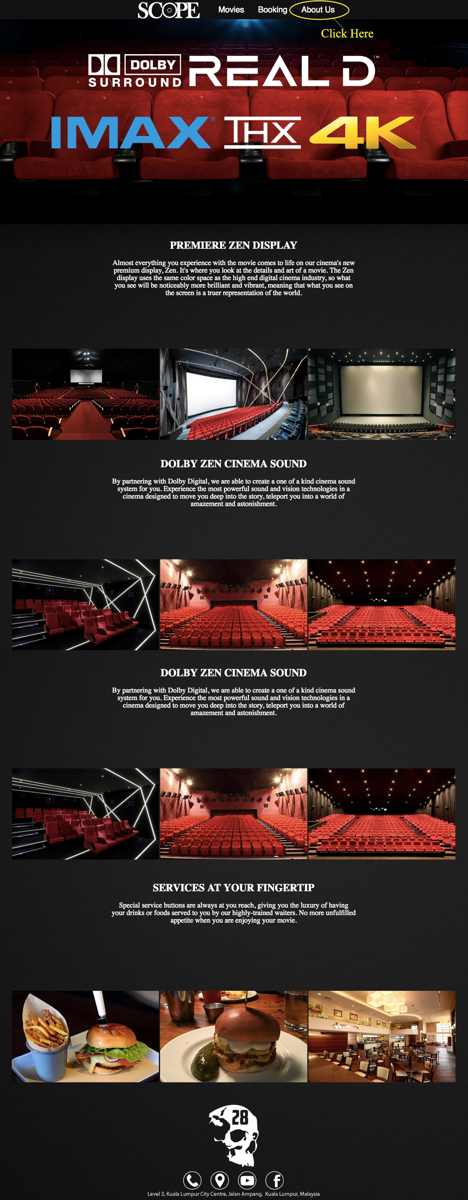Both categories of user can click on ‘about us’ to see more information about our website and the cinema.

1. **Feature Overview**

One of the innovations that we have created is the use of phone numbers as IDs for the purchase of movie tickets. In the 21st century, one of the most frustrating thing happens to people daily is forgetting their online account’s username and password.

After brainstorming for several hours, our company decided to take a slightly different approach in tackling this problem. Instead of having the user to create an account and sign in every time he or she wants to buy a ticket, we decided to let user purchase movie tickets just by entering their phone number.

As mobile phone users rapidly increasing, the chances of user forgetting their phone number is lower. Therefore, phone number is a good base to be a special ID. Once tickets are purchased, a sms will be sent to the user’s phone and user just need to show the sms at the cinema’s counter to watch the movie.

1. **Website’s setup tutorial**
2. Go to the google drive link provided and download all the files.
3. Turn on Xampp and go to <http://localhost/phpmyadmin/>
4. Then, go to the database section and create a new database named “dead @ 28 website”.
5. Click the new database, and import the mysql file that is given in the project’s folder.
6. The website’s database is now successfully created and able to record and transfer information with the website.

Google drive link to our website’s codes:

<https://drive.google.com/open?id=0B6tUZYsWhhgddWc3WHFabTFablU>

1. **References**

**Website design:**

1. [**https://www.templatemonster.com/demo/51822.html**](https://www.templatemonster.com/demo/51822.html)
2. [**https://www.templatemonster.com/demo/53142.html**](https://www.templatemonster.com/demo/53142.html)
3. [**http://www.wix.com/website-template/view/html/1732?originUrl=http%3A%2F%2Fwww.wix.com%2Fwebsite%2Ftemplates%2Fhtml%2Fbusiness%2F1&bookName=&galleryDocIndex=3&category=business**](http://www.wix.com/website-template/view/html/1732?originUrl=http%3A%2F%2Fwww.wix.com%2Fwebsite%2Ftemplates%2Fhtml%2Fbusiness%2F1&bookName=&galleryDocIndex=3&category=business)
4. [**https://www.apple.com**](https://www.apple.com)

**Database design:**

1. [**https://stackoverflow.com/questions/tagged/mysql**](https://stackoverflow.com/questions/tagged/mysql)
2. [**https://www.phpmyadmin.net/docs/**](https://www.phpmyadmin.net/docs/)

**Art and images:**

1. [**https://images.google.com**](https://images.google.com)
2. [**https://www.pinterest.com**](https://www.pinterest.com)
3. [**https://www.youtube.com**](https://www.youtube.com)